SMART GYM TRAINER & FITNESS PLANNER
A Machine Learning Based Fitness Assistance System

1. Abstract
Maintaining physical fitness has become an important part of modern lifestyles. However, many people who go to the gym lack proper guidance regarding workout routines and fitness planning. Beginners often struggle to select suitable exercises, track their progress, and maintain a consistent fitness schedule.
The Smart Gym Trainer & Fitness Planner is an interactive web application developed using Python and Streamlit. The system analyzes user fitness data such as age, height, weight, daily steps, and workout time to determine the user's fitness level. Based on this analysis, the application provides personalized workout recommendations, weekly workout plans, calorie burn estimation, and progress visualization.
The project demonstrates how Machine Learning concepts such as Unsupervised Learning and Clustering can be used to categorize users based on activity levels and provide appropriate fitness guidance.
The system serves as a virtual fitness assistant that helps users maintain a healthy lifestyle through structured workout planning and fitness monitoring.

2. Introduction
In recent years, awareness about health and physical fitness has increased significantly. Many individuals join gyms or start exercising to improve their health. However, without proper knowledge and planning, people often perform ineffective workouts or lose motivation quickly.
Fitness planning requires understanding personal health data such as body weight, height, activity levels, and fitness goals. Professional trainers provide personalized guidance, but not everyone has access to a personal trainer.
To address this issue, the Smart Gym Trainer & Fitness Planner application has been developed. The system allows users to enter their fitness details and receive personalized recommendations for workouts and fitness improvement.
The application uses Streamlit to create an interactive web interface where users can easily input their data and visualize their fitness analysis. The project also demonstrates the use of machine learning concepts for grouping users based on activity patterns and recommending suitable exercises.
This system helps users track their progress, maintain consistent workouts, and improve their overall fitness.

3. Objectives of the Project
The main objectives of this project are:
• To design a user-friendly fitness assistance application.
• To analyze user health and activity data.
• To calculate Body Mass Index (BMI) for health analysis.
• To identify user fitness levels based on daily activity.
• To recommend exercises based on fitness goals.
• To generate weekly workout plans.
• To estimate calories burned during workouts.
• To visualize user fitness progress using charts.

4. Problem Statement
Many individuals who start exercising lack proper knowledge about effective workout planning. Without guidance, users may perform incorrect exercises, fail to maintain consistency, or become discouraged due to lack of visible progress.
Common issues faced by gym beginners include:
• Lack of knowledge about suitable exercises.
• Absence of structured workout schedules.
• Difficulty tracking fitness progress.
• Lack of motivation to continue exercising.
The Smart Gym Trainer & Fitness Planner system aims to solve these problems by providing personalized workout recommendations and fitness analysis based on user data.

5. Technologies Used
The development of this project involves the following technologies:
Programming Language
Python
Framework
Streamlit – Used to build the web-based interactive interface.
Machine Learning Concepts
• Unsupervised Learning
• Clustering
• K-Means Clustering
Development Tools
• Python Environment
• Visual Studio Code / PyCharm
• Web Browser

6. Machine Learning Concept Used
The project demonstrates concepts from machine learning, particularly unsupervised learning techniques.

Unsupervised Learning
Unsupervised learning is a type of machine learning where the system analyzes data without predefined labels. The algorithm identifies patterns and relationships within the data automatically.
In the context of this project, unsupervised learning helps group users based on their activity levels and fitness characteristics.

Clustering
Clustering is a technique used to group similar data points into clusters. In this project, clustering can be used to categorize users based on their activity data such as daily steps, workout time, and BMI.
Users may be grouped into categories such as:
Low Activity Users
Moderately Active Users
Highly Active Users

K-Means Clustering
K-Means clustering is one of the most widely used clustering algorithms. It divides data into a fixed number of clusters based on similarity.
For example:
Cluster 1 – Beginner fitness level
Cluster 2 – Intermediate fitness level
Cluster 3 – Advanced fitness level
Based on the cluster a user belongs to, the system can recommend suitable exercises and workout routines.

7. System Architecture
The system follows a simple architecture:
User Input → Data Processing → Fitness Analysis → Recommendation System → Result Display
Steps:
- The user enters personal fitness data.
- The system calculates BMI and analyzes activity levels.
- The system identifies the user's fitness category.
- Workout recommendations are generated.
- Results are displayed through an interactive dashboard.

8. Features of the System
The Smart Gym Trainer & Fitness Planner includes the following features:

BMI Calculation
The system calculates BMI using height and weight to determine body health status.

Activity Level Detection
The application categorizes users based on their daily step count.

Exercise Recommendation
Exercises are suggested based on the user's fitness goals.

Weekly Workout Planner
A weekly schedule helps users maintain consistent workouts.

Calories Burn Estimation
The system estimates calories burned during workouts.

Fitness Progress Visualization
Charts display step progress over time.

Motivation System
Motivational messages encourage users to stay consistent.

9. Screenshots of the System
This section shows the graphical interface of the Smart Gym Trainer & Fitness Planner application developed using Streamlit. The screenshots illustrate how users interact with the system and how the results are displayed.
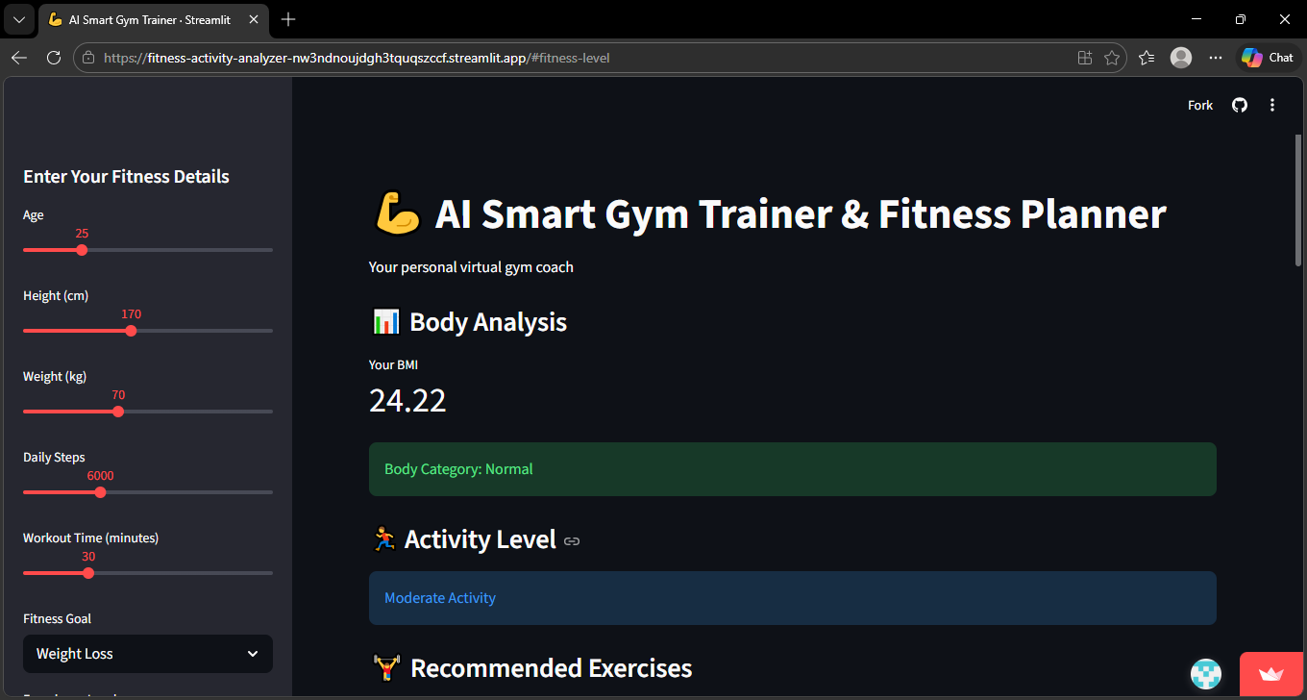
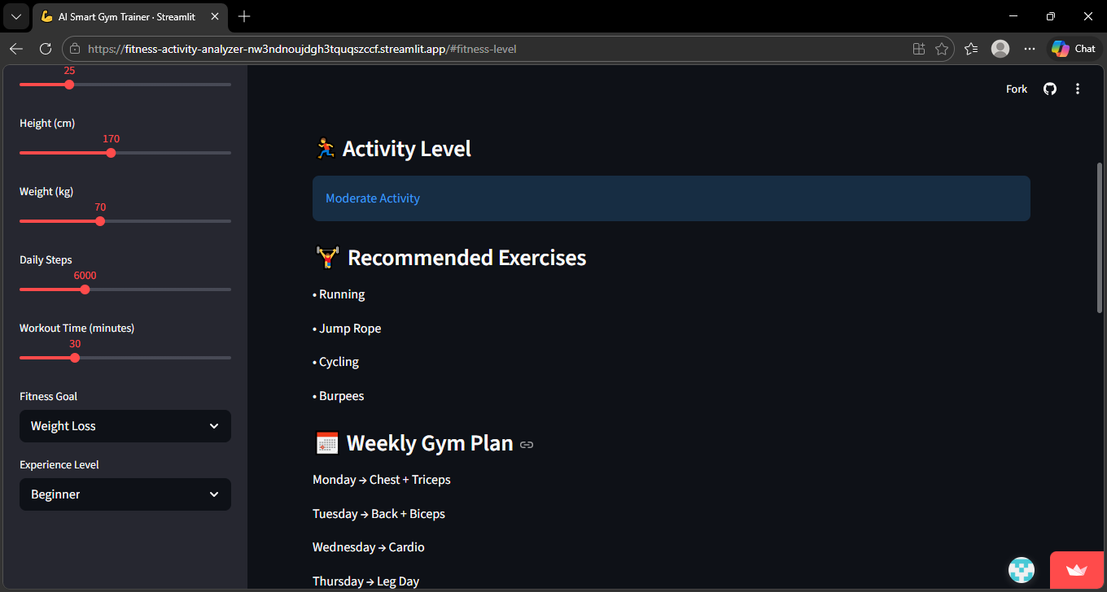

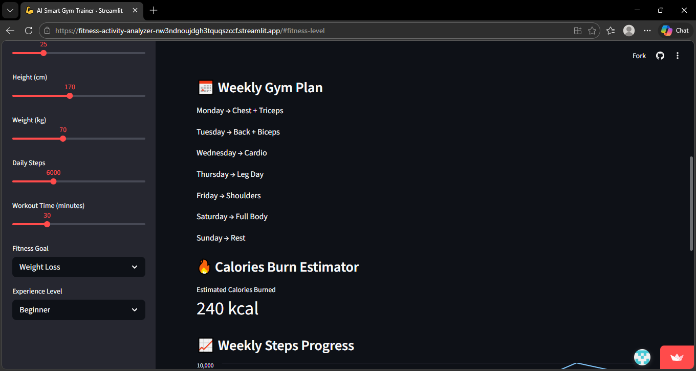

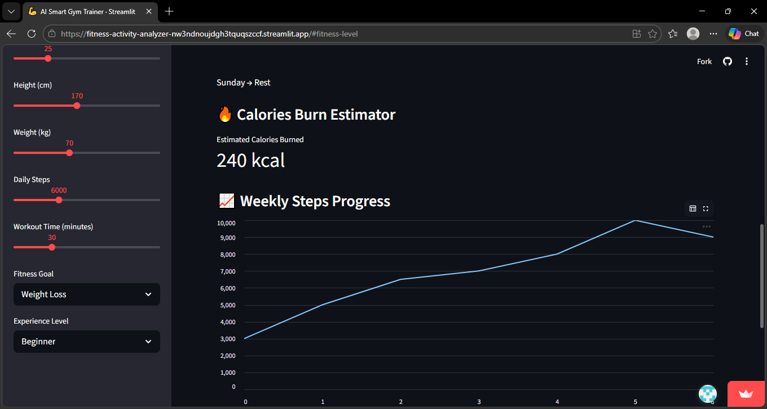
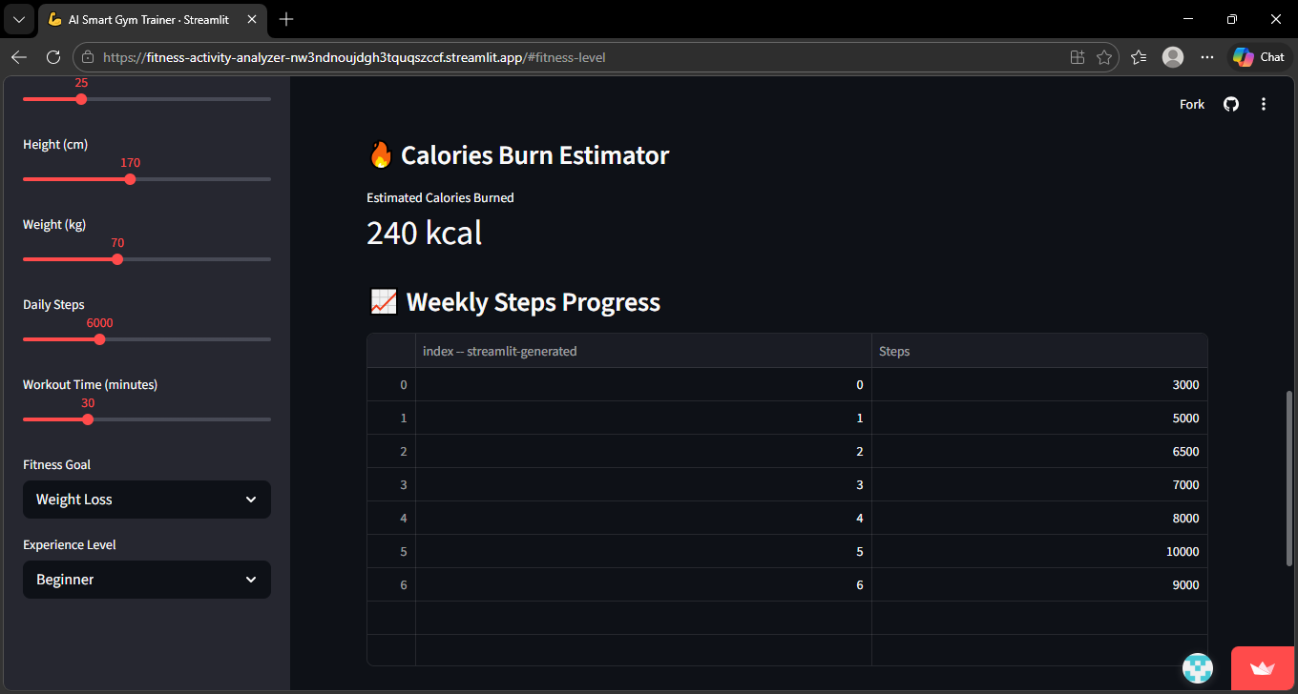

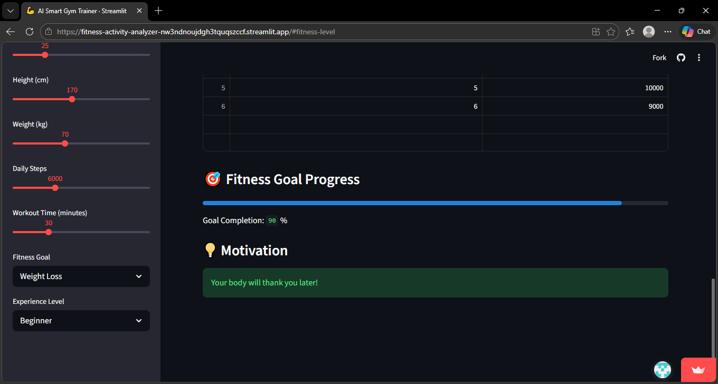

10. Advantages of the System
• Easy to use and interactive interface.
• Helps beginners plan workouts effectively.
• Provides personalized fitness suggestions.
• Tracks user fitness progress.
• Encourages a healthy lifestyle.

11. Future Enhancements
The system can be improved with advanced features such as:
• Integration with wearable fitness trackers.
• Advanced machine learning models for fitness prediction.
• Diet recommendation systems.
• Exercise video demonstrations.
• Mobile application integration.

12. Conclusion
The Smart Gym Trainer & Fitness Planner project demonstrates how modern technologies can be used to create useful applications that promote health and fitness. By analyzing user fitness data and providing personalized workout recommendations, the system acts as a virtual fitness assistant.
The use of Streamlit enables the development of an interactive and user-friendly interface, while machine learning concepts such as clustering help categorize users based on activity patterns.
This project provides a foundation for developing advanced AI-based fitness systems that can assist users in achieving their health goals.

